**Application Design Document:**

**GitHub Links:**

GitHub Repository: <https://github.com/jwhite96/ISAD251>

Prototype page: <https://github.com/jwhite96/ISAD251/blob/master/README.md>

**Storyboard:**

**Customer Storyboard:**

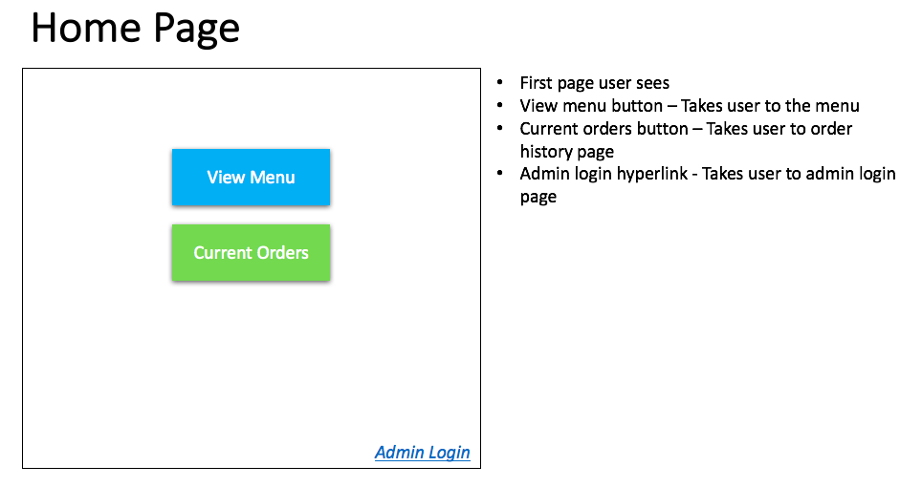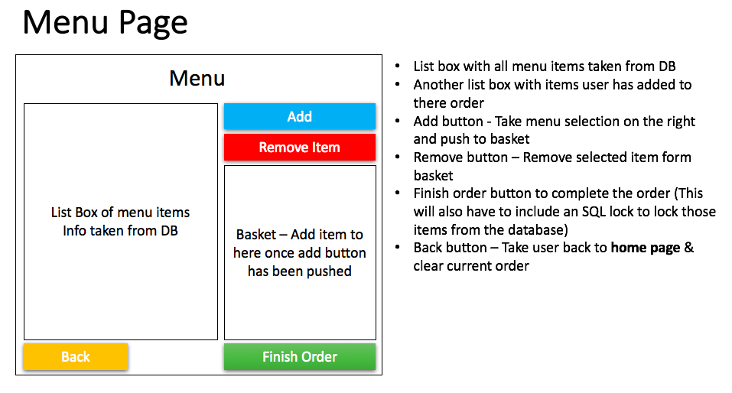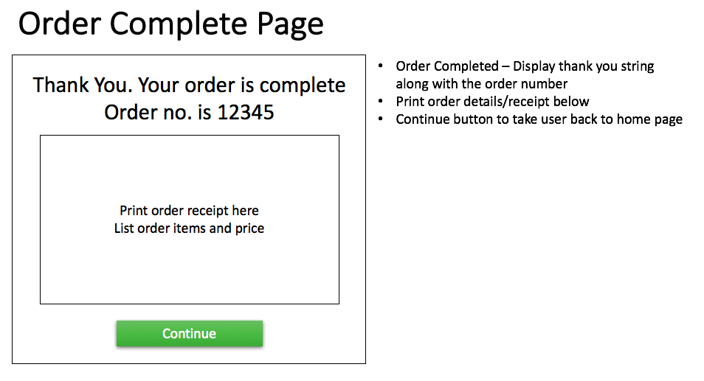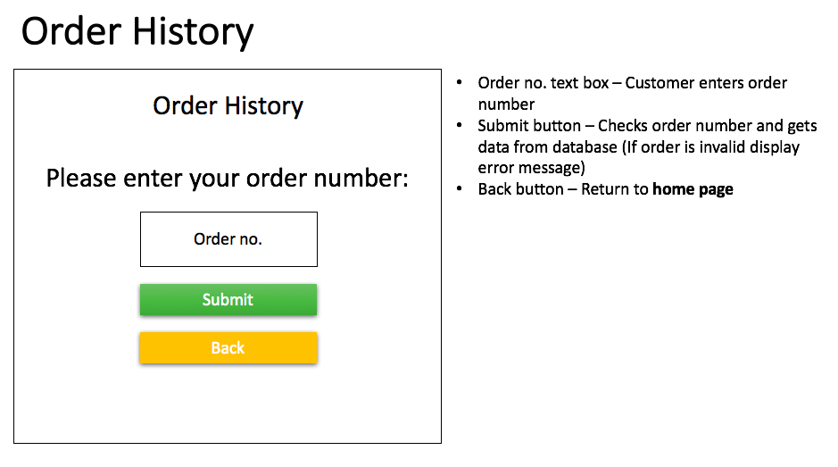

**Admin Storyboard:**

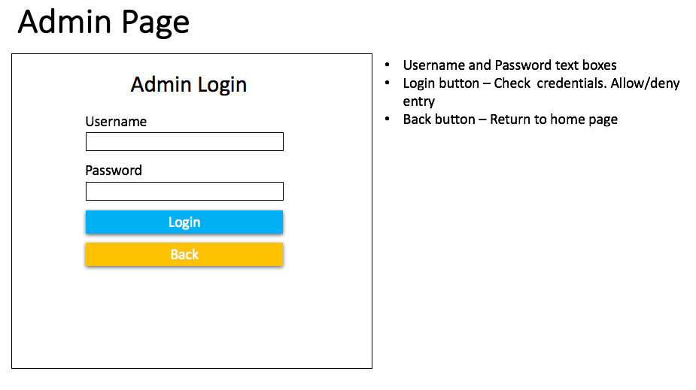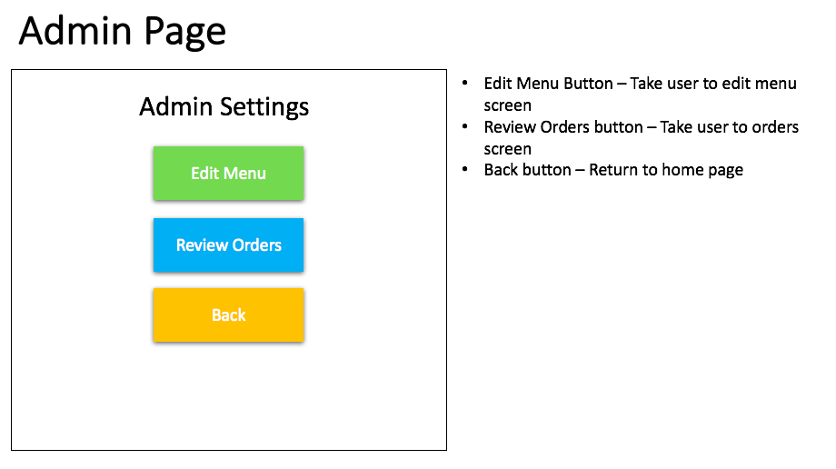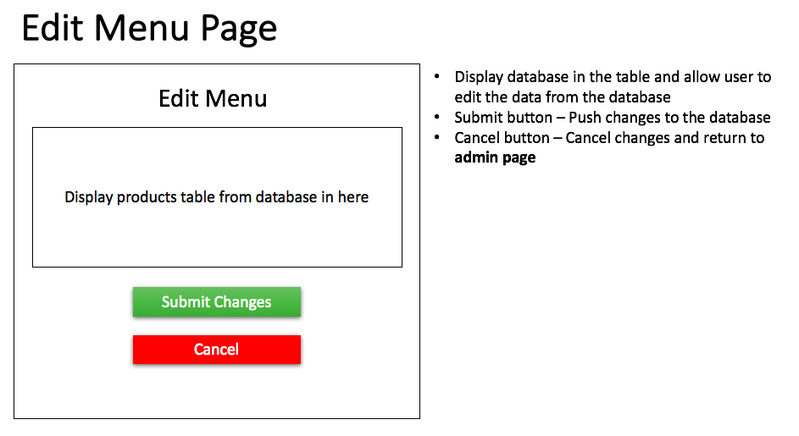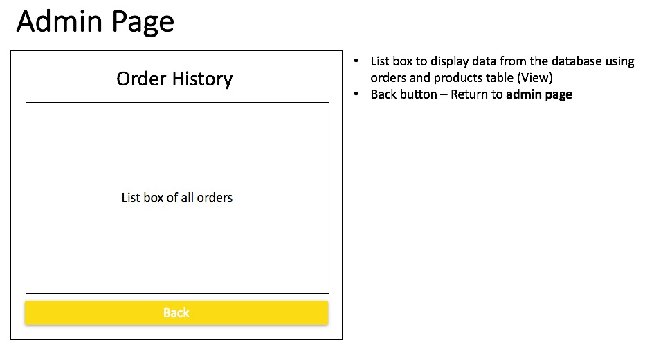

**Entity-Relationship Diagram:**

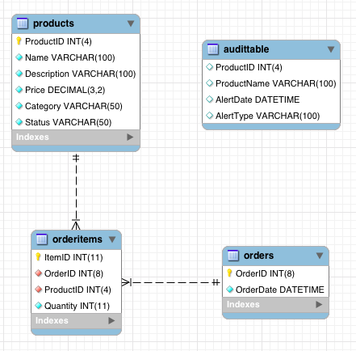

**UML Diagrams:**

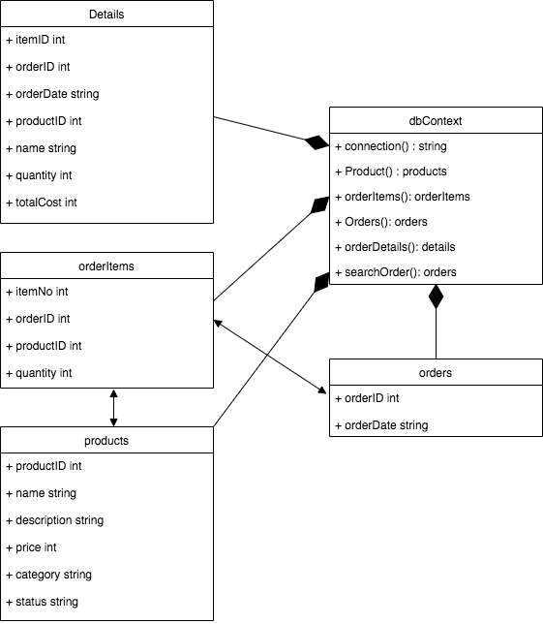

**Feedback & Review:**

**Pre-development feedback:**

**Peer Review carried out by:** Conor Skipper **Date:** 21/10/2019

**Task conducted:**

*Customer placing an order*

**Was the task easy to carry out? (If no or not really, please say why)**

*Yes. Interface is clear and easy to understand*

**Did you encounter any errors? (If yes, please explain what)**

*Not Applicable*

**Did the author have to explain how to use anything? (If yes, what?)**

*Brief demo of how each functionality works*

**Did you gain any inspiration for your own practice? (If so what?)**

*Yes. Creating a review order/edit order screen before order is placed to avoid confusion for the customer*

**What constructive advice would you give the author for presenting their work/code in future?**

*Talking through things a bit more slowly and not rushing*

**Post-development feedback:**

**Peer Review carried out by:** Adam Crease **Date:** 9/01/2020

**Task conducted:**

*Editing an existing menu item*

**Was the task easy to carry out? (If no or not really, please say why)**

*Slight confusion about how to edit at first. Attempted to push edit button first before changing the item characteristics*

**Did you encounter any errors? (If yes, please explain what)**

*Yes, an error occurred when I typed an apostrophe into a textbox*

**Did the author have to explain how to use anything? (If yes, what?)**

*Author had to explain process after first attempt failed*

**Did you gain any inspiration for your own practice? (If so what?)**

*No*

**What constructive advice would you give the author for presenting their work/code in future?**

*I liked how the website looked, I have no feedback.*

**Review:**

After the pre-production peer review I decided to drastically change the user interface as the storyboard looked more like an application (e.g. mobile app, windows form etc.) rather than a website. There was also changes to how things would be displayed to user upon entering the site. Instead of having multiple windows and different ways to access each functionality, the user would be presented with all their specific requirements upon load making it less confusing to new users and easier to access the required functions more efficiently.

Following the post-production feedback, it became apparent that although the customer side of the application was easy to use and understand, the admin side required a bit of direction in order to carry out most of the functionality. The problem mostly came from trying to edit an existing item. Having to edit an item before pushing an edit item seemed confusing to the user as most applications require a button to be clicked before any action can occur. Also, due to the way the database stores its data, any special characters would cause the program to crash as found out when the user tried to input an apostrophe inside one of the textboxes. This was helpful to know as this was not picked up during testing.

In Conclusion, the main changes would be:

* Ability for a customer to place an order on checkout and push this to the database
* To improve the admin functionality to make it more user friendly and easier to carry out set tasks without much guidance.
* Include more exception handling to prevent the program from crashing after unexpected errors occur.
* Improvements to the PHP functionality to make it more flexible instead of being rigid and prone to errors/crashed during runtime.
* More use of SQL views to display more coherent data to the user (e.g. order history)

**References:**

Font-awesome icons:

<https://cdnjs.cloudflare.com/ajax/libs/font-awesome/4.7.0/css/font-awesome.min.css>

W3.css stylesheet:

<https://www.w3schools.com/w3css/4/w3.css>

Images: